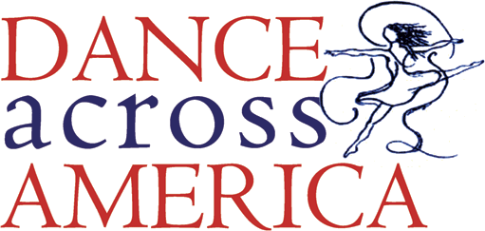
Yes, we want to join in and DANCE ACROSS AMERICA!
Please complete the information below and return it to DreasDream@aol.com
at least 3 weeks prior to your event.
We will make every effort to get local press attention for your event!

Studio Name:
Date of Event:
Location of Event:
Time of Event:
Brief Description of Event (please including approx. # of dancers participating, what the event will entail, etc.):
Dance Studio Street Address:
City, State, Zip Code:
Owner/Director Name:
E-mail:
Phone:
For local press, please fill out the below:
Local Newspaper:
Newspaper Contact Name or Dept:
Newspaper Phone:
E-mail:

[Pledges may be solicited any time prior to or after event.]
Thank you for taking the time to “let your heart move your feet!”TM

